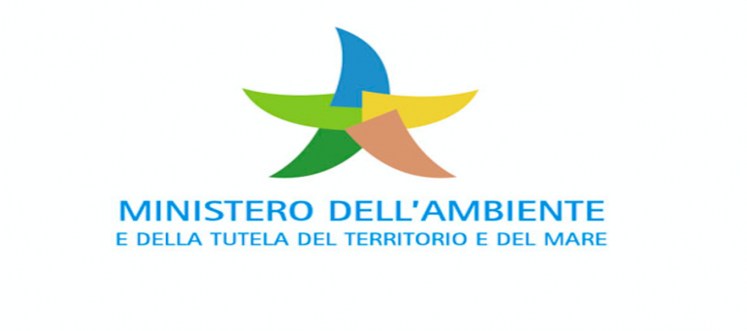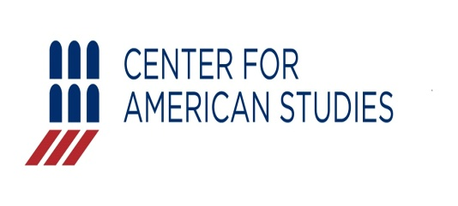

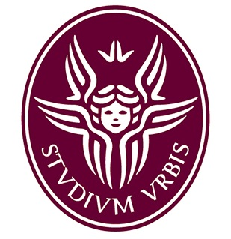

**Dottorato in Diritto Pubblico, Comparato ed Internazionale. Dipartimento di Scienze Politiche**

U.S. – E.u.

ENVIRONMENTAL LAW COLLOQUIUM

*MAY 30, 2019*

*Center for american studies*

*Rome*

*Via M. CAETANI, 32*

#### C:\Users\Giovanni\Desktop\bandiera Europa-stati-uniti.jpeg

**CLIMATE CHANGE**

- PROF. M. GERRARD, *Columbia Law School* (keynote speaker), “Status of global and U.S. legal efforts to fight climate change". **- Dr. G. Antonelli, Intoduction**

- PROF. F. FRACCHIA, *Bocconi University,* “Environmental protection: a matter of rights only?”.

*-* PROF. J. DERNBACH, *Wiedener University,* “Legal pathways to deep decarbonization in the U.S. and Europe*”.*

*-* MR. S. FULTON, *President Environmental Law Institute,* "Tools for progress in developing and transitional economies".

**Light lunch**

**AFTERNOON SESSION 2.30 p.m.**

***Chair Prof. F. Giglioni***

**GREEN PUBLIC PROCUREMENT - Dr. G. Antonelli, Introduction**

- PROF. C. YUKINS, *George Washington University School of Law,* and PROF. G.M. RACCA, *University of Turin*, "Sustainability in U.S. procurement".

- PROF. R. CARANTA, *University of Turin,* “User-friendly GPP: LCC & labels”.

- PROF. S. VALAGUZZA, *University of Milan,* “GPP and collaborative behaviours”.

- PROF. F. DE LEONARDIS, *University of Macerata,* “ GPP and circular economy”.

## MORNING SESSION 9.30 a.m.

## Chair Prof. S. Marchisio

**GREETINGS**

**-** MS. C. VENTURA, *Executive Director Center for American Studies.*

- PROF. E. GAUDIO, *President Sapienza* University *of Rome.*

- MR. S. COSTA, *Italian Minister of Environment.*

- MS. C. DE MARS, *U.S. Embassy of Rome.*

*-* PROF. A. CLARIZIA, *Sapienza University of Rome.*

**REGULATION AND ENVIRONMENTAL LAW**

**-** PROF. J. FREEMAN, *Harvard Law School* (keynote speaker) - **Dr. G. Antonelli, Introduction**

- PROF. S. MARCHISIO, *Sapienza University of Rome*, “International governance and MEAs”.

- PROF. E. PICOZZA, *Tor Vergata University of Rome, “*Neurolaw and environment”.

- PROF. M. CAFAGNO, *Insubria University,* “Law and economics”.

*-* PROF. G. DELLA CANANEA, *Bocconi University*, “Environmental regulation and citizens’ participation”.

- PROF. A. POLICE, *Tor Vergata University of Rome,* “Environmental law and judicial enforcement”.

**U.S.-E.U.: SECTORAL POLICIES AND LAWS IN THE ENVIRONMENTAL FIELD**

- PROF. F. GIGLIONI, *Sapienza University of Rome,* “The contribution of cities to environmental protection in the EU: hints of a recent case law”.

- PROF. V. HEYVAERT, *London School of Economics,* “The governance of transnational environmental regulation*”*.

- PROF. M. SCANLAN, *Vermont Law School,* “Cooperatives and advancing environmental sustainability: Spain & US”.

- PROF. M. V. FERRONI, Sapienza University of Rome, “Right of access to environmental information”.

- PROF. M. DELSIGNORE, *Bicocca University,* “Food safety and consumer protection”.

*-* DR. G. ANTONELLI, C. CAMPANARO, *Sapienza University of Rome*, “Public regulation and animal welfare: food procurement and environmental sustainability”.

- DR. C. MARI, *Sapienza University of Rome*, “Simplification of procedures for renewable energy projects”.

**ORGANISING COMMITTEE:**

**PROF. M.V. FERRONI**

**PROF. F. GIGLIONI**

**DR. G. ANTONELLI**

**For info and reservations:**

**giovanni.antonelli@uniroma1.it**