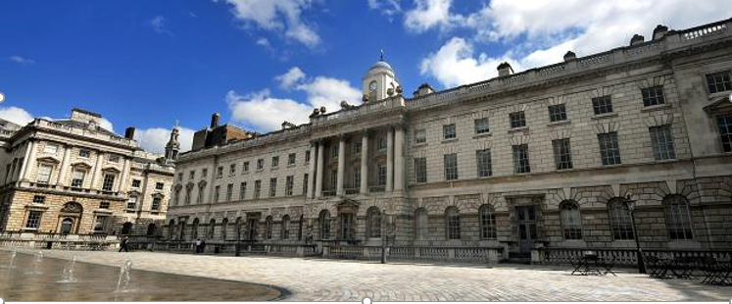
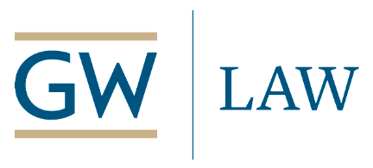
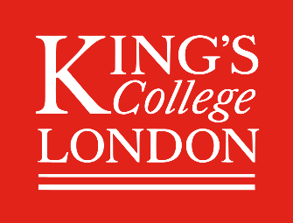
King’s College, London – George Washington University Law School
Annual Symposium on Transatlantic Issues in Public Procurement Law

Conflicts in Public Contract Administration: Shared Lessons

King’s College, London – Dickson Poon School of Law – 16 March 2020 – 10:00
Procurement reform internationally has until now centered on contract formation, and contract administration and its inevitable disputes (and fraud) too often have been ignored. This symposium seeks to remedy that, by bringing together judges, lawyers, and academics from both sides of the Atlantic to share ways forward to a sound approach for resolving conflicts in contract administration.
- Speakers include: Helena Rosén Andersson (Supreme Administrative Court, Sweden) – Sir Vivian Ramsey (Singapore Int’l Commercial Court) - Judge Katja Hoegh, Chair, Østre Landsret (High Court of Eastern Denmark) - Mrs. Justice O’Farrell DBE, Technology & Construction Court (London)* - Benedetta Audia (UNOPS) - Caroline Nicholas (UNCITRAL)* - Marcia Madsen, Mayer Brown (Washington) - Craig Holman, Arnold & Porter (Washington) - Michael Bowsher QC, Monckton Chambers & King’s College, London - Christopher Yukins & Steven Schooner, George Washington U. Law School –Paul Lalonde, Dentons (Toronto) - Jane Jenkins & Kate Gough, Freshfields Bruckhaus Deringer (London) - Francois Lichere, Université Jean Moulin Lyon 3 - Roland Stein, BLOMSTEIN (Berlin) - Gabriella Racca, U. of Turin - Jeri Somers, U.S. Civilian Board of Contract Appeals (Washington) - John Pachter, Smith Pachter (US) - David Mosey, Center for Construction Law & Mg’t, King’s College, London - Paul Khoury, Wiley Rein (Washington) - Marta Andhov, U. of Copenhagen - Irena Georgieva, PPG Lawyers (Sofia) - Vera Eiró, Linklaters (Lisbon) [note: *invited]

Panels will run to 17:00, followed by light refreshments and discussion of a new book, Joint Public Procurement and Innovation: Lessons Across Borders (Bruylant) (G. Racca & C. Yukins, eds.)
Registration and Event Information:
https://www.eventbrite.co.uk/e/kcl-gwu-annual-symposium-tickets-80272476137
publicprocurementinternational.com/kcl-gwu-annual-symposium-contract-administration-march-16-2020/

With generous support from:
