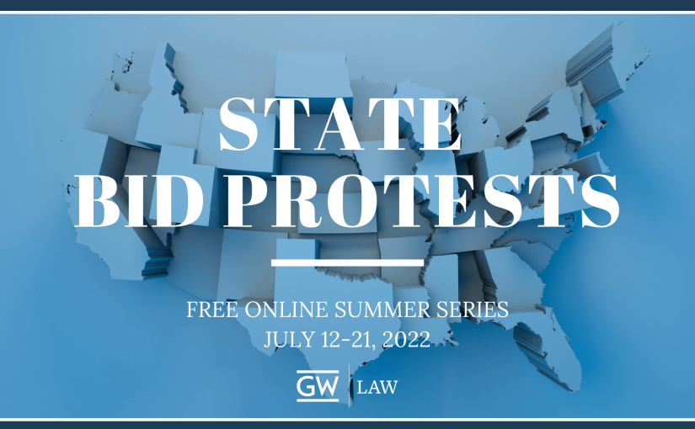

State Bid Protest “Summer Series”

July 12-21, 2022

Mock Bid Protest Exercise for Session 4: July 21

This protest is set in the fictional state of West Carolina. West Carolina has adopted the 2000 version of the ABA Model Procurement Code (MPC) into the “West Carolina Procurement Code,” and also has adopted the MPC’s model implementing regulations (the “West Carolina Procurement Regulations”).

West Carolina’s leading public health facility, West Carolina Hospital (WCH), regularly uses federal grants funding to run summer research programs that assess the effects of industrial pollution on workers in West Carolina. The grants to the WCH are covered by federal agency regulations which follow the Office of Management and Budget (OMB) Uniform Guidance, including Sections 200.318 through 200.327 on procurement using federal grants funding, and specifically Sections 200.318(c) and 200.319(b) on organizational conflicts of interest.

Partly to ensure that institutions such as the WCH meet federal grants requirements in accordance with Section 11-301 of the West Carolina Procurement Code, and because the West Carolina Procurement Regulations do not cover organizational conflicts of interest beyond a passing reference in Section R4.202.01.2 (per the competition requirements in Article 4 of the MPC), the West Carolina legislature has considered passing a statutory provision which mirrors Minnesota’s organizational conflict of interest statute, Minnesota Statutes 2021, section 16C.04, subdivision 3, including the definitional provision at section 16c.02, subdivision 10(a). Those Minnesota provisions broadly track federal organizational conflict of interest provisions at FAR Subpart 9.5, which are discussed in detail in Daniel I. Gordon, Organizational Conflicts of Interest: A Growing Integrity Challenge (February 8, 2005).

The contracts to support this year’s summer research programs at WCH are to be awarded competitively, including the contract to provide medical testing equipment. The solicitation for the medical testing equipment contract was released three months ago, and proposals are due soon. The specifications for the contract say that the awardee contractor must include portable spirometers in the suite of equipment which can be ordered as needed by WCH. The Mayo Clinic describes these as a portable “diagnostic device that measures the amount of air you're able to breathe in and out and the time it takes you to exhale completely after you take a deep breath.” Because there are no industrial activities likely to cause lung disease nearby to WCH, spirometers have been used only occasionally in the past during the summer research programs.

The company which has historically provided medical testing equipment for the WCH summer research program is a small local business, West Carolina Medical Equipment, Inc. (WCME). WCME has historically benefitted from the small business policies set forth in Article 11 of the West Carolina procurement code. WCME is concerned because it does not provide spirometers as part of its suite of equipment. World Equipment (WE), a large international provider, does.

On an open records request for documents that relate to the pending procurement, the Project on Good Procurement (PGP), a civil society group, received a copy of the following email chain involving a junior WCH contracting officer, Charles Osborne, and Abraham Honnette, the head of WE’s medical testing equipment division. Four weeks after PGP posted the email chain on its website, an employee of WCME found the email chain on the PGP website. The chain read as follows:

_________________________________________________________________________

5 January, 09:10:18

Dear Abe:

I am following up on your team’s recommendations regarding the upcoming testing equipment contract. Although the purchase order for your consulting services has expired, your recommendations were very well received, and our integrated procurement team really benefited from our exchanges with your team. We appreciate your suggestion that we revise and modernize our standard specifications by consolidating our requirements into one omnibus contract which covers all possible research contingencies.

Concerns have been raised, though, that we honor the state’s procurement code and ensure that any advice we have received is independent and impartial. Could you help us address those concerns?

Thank you in advance,

Charlie Osborne

____________________

6 January, 10:04:01

Dear Charlie:

Thanks very much for your note. We very much hope to be able to provide the Hospital with its critically needed testing equipment in the coming months. We have reviewed your request internally, and you can rest assured that the consultants who worked with the Hospital in understanding the medical equipment market are not those who work on our contracting matters -- those are entirely separate teams. West Carolina’s legal requirements have therefore been fully met.

Respectfully submitted,

Abe

_____________________

8 January, 08:55:01

Dear Abe:

Thanks for your follow-up. I discussed it yesterday with our Office of General Counsel, and we are good to go.

Charlie

____________________________________________________________________________

Two days after its employee found the email chain above (and before proposals were due), WCME filed a bid protest with the West Carolina Procurement Appeals Board (WCPAB), a board which was established in accordance with Section 9-501 of the WC Procurement Code. In handling bid protests, the Board operates under rules adopted directly from Appendix 9-506 to the MPC’s model implementing regulations.

PGP opted not to file a parallel protest with the Board.

The WCME protest referenced the email chain above, and alleged that WE should be disqualified because of (1) an organizational conflict of interest, and (2) its representations to WCH. WE has sought to intervene in the protest, although intervention is not discussed in detail in the West Carolina Procurement Code or Procurement Regulations.

Exercise

A hearing on these protests will constitute our exercise on the last night of the webinar series, on July 21.

Because of the rapidly approaching proposal due date, under Protest Rule 9 of the Board’s rules an expedited videoconference hearing has been scheduled by the Board, which will be joined by all members of the Board. Board members will be asking questions and seeking clarification throughout the hearing. For efficiency, preliminary matters (such as standing and jurisdiction) will be addressed along with the merits. The agency report has been waived by the Board, and argument will be based solely on the document reproduced above and the applicable law.

For the exercise, participants will be assigned to one of the teams listed below. Please divide the issues to be addressed in the argument equitably among your team members. The teams will address each issue in the following order:

Protester WCME  Joseph Dobbert  Jacob Green | Agency WCH  Sareesh Rawat  Joseph Tinger | Intervenor WE  Keith Montoya  Christopher Yukins

Each team should expect to have 3 minutes to address each issue listed below. PowerPoint slides are allowed -- each team using slides should send its package of slides to Professor Yukins (cyukins@law.gwu.edu) at least one hour before the session begins. At their discretion, the Board members (who will be played by administrative judges and senior procurement attorneys) may allow time for rebuttal.

ISSUE
Introduce Co-Counsel on Team and Overview of Arguments
Board’s Jurisdiction
Protesters’ Standing
Timeliness of Protest
Whether WE’s Intervention Should Be Allowed
Should WE Be Disqualified Due to an Organizational Conflict of Interest?
Should WE Be Disqualified Due to Representations Made?
Wrapping Up and Relief Requested

Each team should name a “team leader,” who can coordinate among the team members (and with other teams) by videoconference, email or otherwise. Coordination is up to the teams. If you have questions, please feel free to contact Professor Christopher Yukins, cyukins@law.gwu.edu.

